You are given a string word containing **distinct** lowercase English letters.

Telephone keypads have keys mapped with **distinct** collections of lowercase English letters, which can be used to form words by pushing them. For example, the key 2 is mapped with ["a","b","c"], we need to push the key one time to type "a", two times to type "b", and three times to type "c" *.*

It is allowed to remap the keys numbered 2 to 9 to **distinct** collections of letters. The keys can be remapped to **any** amount of letters, but each letter **must** be mapped to **exactly** one key. You need to find the **minimum** number of times the keys will be pushed to type the string word.

Return *the* ***minimum*** *number of pushes needed to type* word *after remapping the keys*.

An example mapping of letters to keys on a telephone keypad is given below. Note that 1, *, #, and 0 do **not** map to any letters.

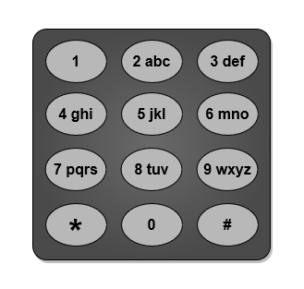

**Example 1:**

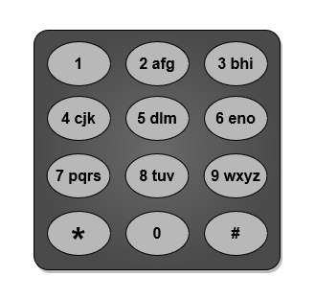

Input: word = "abcde"  
Output: 5  
Explanation: The remapped keypad given in the image provides the minimum cost.  
"a" -> one push on key 2  
"b" -> one push on key 3  
"c" -> one push on key 4  
"d" -> one push on key 5  
"e" -> one push on key 6  
Total cost is 1 + 1 + 1 + 1 + 1 = 5.  
It can be shown that no other mapping can provide a lower cost.

**Example 2:**

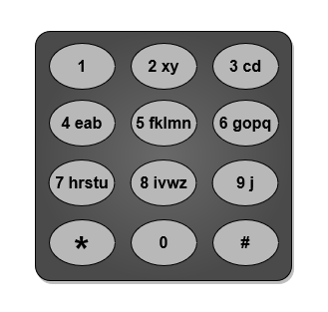

Input: word = "xycdefghij"  
Output: 12  
Explanation: The remapped keypad given in the image provides the minimum cost.  
"x" -> one push on key 2  
"y" -> two pushes on key 2  
"c" -> one push on key 3  
"d" -> two pushes on key 3  
"e" -> one push on key 4  
"f" -> one push on key 5  
"g" -> one push on key 6  
"h" -> one push on key 7  
"i" -> one push on key 8  
"j" -> one push on key 9  
Total cost is 1 + 2 + 1 + 2 + 1 + 1 + 1 + 1 + 1 + 1 = 12.  
It can be shown that no other mapping can provide a lower cost.

**Constraints:**

* 1 <= word.length <= 26
* word consists of lowercase English letters.
* All letters in word are distinct.